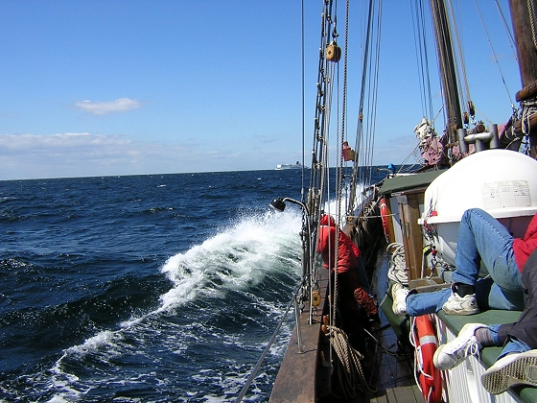
Time to register:
The NFKK course in practical communication 2019
Communicate and lead!
Communication is the basis for interacting with our clinical environment. It is a difficult field to manage and is not included in traditional medical specialist training. New knowledge and experience is needed. This course is focused on giving young doctors insight, training and basic tools to improve their communication skills with clinical colleagues.
Workshops will be arranged with practical training in different situations. There will be time for discussions and networking.
The course will be held under basic conditions onboard a sailing vessel Helene and include seminars, workshops and shorter sailing trips in the waters off Malmö, Sweden. No naval experience is needed but bring your rainproof gear!. Professional crew is responsible for maritime passages and safety. Accommodation will also be onboard (don’t forget your sleeping bag).
A maximum of 12 students can be admitted, so register early!
The course is led by several experienced communicators:
- Sverre Sandberg, Norway, has worked clinically and scientifically on quality improvement of the post-analytical phase and the interpretation of laboratory results.
- Eva Ajzner, Hungary, is chair of the joint Working Group on Post-analytical Phase of the EFLM (European Federation of Clinical Chemistry and Laboratory Medicine).
- Per Simonsson, Sweden, has a long experience in communication between physicians at the laboratory and their colleagues in clinical care.
- Anna Linko-Parvinen, Finland, and former chairman of NFKK Yngve Thomas Bliksrud, Norway, will further strengthen the Nordic perspectives.
Date. Thursday 190829 - Sunday 190901
Place: Öresund, with departure från Malmö, Sweden. Malmö can easily be reached by train or by air, via Copenhagen Airport.
Registration fee: 3 000 Danish kronor, including board and lodging . The Course is financially supported by NFKK. Swedish participants can apply for travel grants from SFKK.
Registration deadline is 1st April 2019.
Registration can be made by e-mail to per.simonsson@med.lu.se

If you want to read more about a similar previous course on the sailing vessel Helene please see Klinisk Biokemi i Norden vol 19, nr 4, 2007 (http://www.nfkk.org/klinisk-biokemi-i-norden/arkiv/17-klinisk-biokemi-i-norden-2007).
For further information please contact Per Simonsson, per.simonsson@med.lu.se, +46730868915.
Time to register!
Welcome aboard!
Per Simonsson
Foto: TS Helene af Ystad
